WAIVER | WAIVER Specialists
Independent Care Waiver (ICWP) Lead | Kimberlee Boulding  Kimberlee.boulding@dch.ga.gov  470-585-7410
CCSP/SOURCE (EDWP) Waiver Leads  NOW/COMP Waiver Lead | Andrea Streeter  Andrea.Streeter@dch.ga.gov  470-515-6302  Briana Coogler  Briana.coogler@dch.ga.gov  470-456-5482  Marina Kim  Marina.kim@dch.ga.gov  404-904-7647  Shandria Beasley  Shandria.beasley@dch.ga.gov  470-393-1980
General EDWP Waiver Questions | ccsp.messages@dch.ga.gov
General ICWP Waiver Questions | Icwp.messages@dch.ga.gov
Georgia Pediatric Program | Sharon Collins 404.683.5113  scollins@dch.ga.gov
Director of Program and Community Supports (Waivers, LTC, STP, and MFP) | Taesha Ward 470-895-2777  Taesha.ward3@dch.ga.gov
Program and Community Supports Compliance Manager | Vonnie Stelly 470-542-9402  VStelly@dch.ga.gov
Prior Authorization Claims Resolution Manager | Donna Elrod 470-522-9620  donna.elrod@dch.ga.gov

**** Use the Contacts below before emailing the waiver team.

____________________________________________________________________

Billing issues should start with your Gainwell field rep, then Donna Elrod.

Suspensions, revalidation, anything related to your Medicaid contract should be emailed to Provider Enrollment to enrollment@dch.ga.gov.

The Georgia Department of Community Health, HCBS Waiver incident reporting system:

The HCBS Incident Report can be accessed at -
HCBS Incident Reporting System | Georgia Medicaid

Additionally, we have a resources page to assist in training agency staff.

Link to resource page:
https://medicaid.georgia.gov/programs/all-programs/waiver-programs/hcbs-incident-reporting-system-resources

General Services Manual - suspending referrals to providers for failure to report incidents. The responsibility for submission of an incident report falls on the first person to witness or discover the incident regardless of location
Other Contacts

- Provider Enrollment enrollment@dch.ga.gov

- Revalidation, revalidationenrollment2@dch.ga.gov

- CVO, 1 800-766-4456 outreachsupport@verisys.com

- Gainwell- Gainwell Field Representative assistance- GAMMIS website, www.MMIS.georgia.gov, select Contact Information tab, then Contact Us tab. Choose the applicable drop-down from the list. Call 800-766-4456.

Finding a list of active Medicaid providers in GA
https://dch.georgia.gov/ click on ‘providers’ and ‘provider directory’

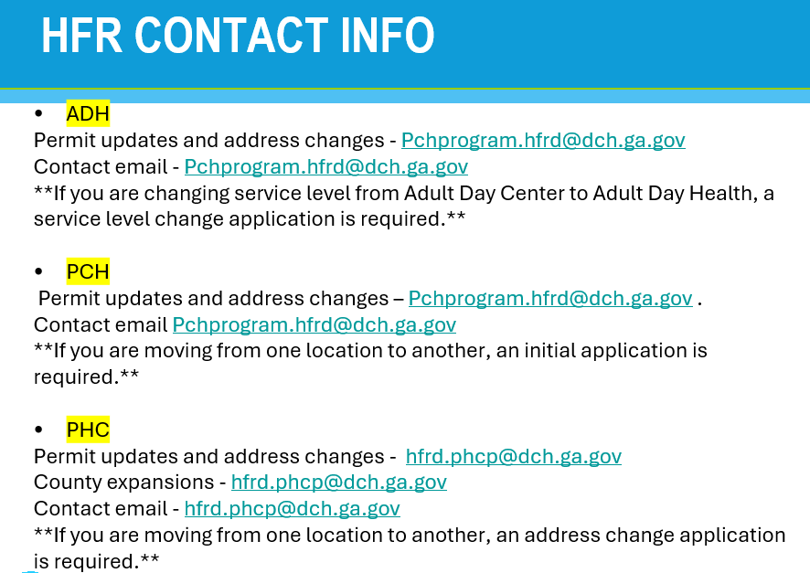

Healthcare Facility Regulation (HFR)- proxy forms/find a facility/complaints
https://dch.georgia.gov/divisionsoffices/hfrd

EDWP Referral Process- AAA contact information-
https://aging.georgia.gov/locations

Online referral system for CCSP referrals to the appropriate AAA- link below

https://hssgaprod.wellsky.com/assessments/?WebIntake=2CBCF6CD-9412-4839-8EF8-5864FA6BA0F9

*The link above is the best way for providers to submit 3rd party referrals if they aren’t sure where they need to go.

ATLANTA 404-463-3333.
CSRA 888-922-4464 and 706-210-2018
Coastal 800-580-6860
Georgia Mountains (Legacy Link) 800-845-5465 and 770-538-2650
Heart 888-367-9913 and 912-367-3648
Middle 478-751-6466
NE 800-474-7540 and 706-583-2546
NW 800-759-2963 and 706-802-5506
River Valley (706) 256-2900 and 800-615-4379
Southern 888-732-4464 and 912-287-5888
SOWEGA 800-282-6612 and 229-432-1124
Three Rivers 866-854-5652 and 678-552-2838
* 866-552-4464, Option 2

Policy Revisions included in the April 2026 Edition of the EDWP Policy Manuals: Remember to review the manuals quarter for policy updates across all four waivers.

Network Meeting attendance-
EDWP Provider Network Meetings consists of statewide meetings in the form of a webinar that are hosted by the Atlanta Regional Commission (ARC).
Providers must go to https://www.empowerline.org/for-professionals/medicaid-elderly-and-disabled-waiver-providers-meeting-information/ to register for each meeting ahead of time. Once registered, each provider will receive a confirmation e-mail that includes the link to join the webinar at the specified time and date.
All network meeting information and presentations will be placed on the ARC Network Meeting webpage.
Policy has been updated January 1, 2026 to require providers must attend all (4) network meetings. General Services Manual. Corrective action will be applied for those providers who are not in compliance.
*Network meeting reminders will ONLY be sent to agencies that have registered at the site to receive the reminders. We encourage all providers to register their email address at the registration site so that they will receive the reminders for themselves.

The format has the capability for DCH to track the time of logging on and off of the meeting for each provider. You must participate in the full meeting to receive credit for attending.

EVV information-

Handouts and recordings- EVV Service Providers | Georgia Medicaid

Email questions to……Evv.medicaid@dch.ga.gov or visit
https://medicaid.georgia.gov/georgia-electronic-visit-verification

The Georgia EVV Program has updated its customer support phone number. The new EVV Customer Support number is (833) 483-5587.
Hours of Operation: Monday – Friday: 8 a.m. – 7 p.m. EST
Closed on Saturdays, Sundays, and state holidays.

Be sure to visit the new Netsmart Support Portal - NetsmartCONNECT — for 24/7/365 support, ticket submissions, FAQs, and training materials.

The website link for the Mobile Caregiver+ EVV Provider Portal is https://evv-dashboard.mobilecaregiverplus.com/auth/login.

Waiver Updates:

- April 2026 Policy Updates
  - No changes – HDM, ALS, ERS, Out of Home Respite, HDS
  - General Services Manual
    - Appendix DD-correction to ALS-F Permit Requirements
    - Section 605.1.12.1- Registered Nurse (RN) must be a resident of GA, not just licensed in the state of GA. This will be confirmed by Enrollment.
  - Case Management Manual
    - Section 1863.14- Correction of Legal Address Zip Code
    - Department of Community Health
    - Section 1867.8 NOTE: All referrals sent to the ADRC from home health agencies or hospitals for their discharge planning process must follow the same referral processes outlined in this manual. Counselors must explain to all callers that individual clients will not be assessed without their knowledge and permission except in cases where the individual cannot give consent, allowing the Counselor to complete assessment with the caller or other representative.
    - Section 1872.21, 1957.2, 2080-Use of Interpreter Services Any applicant or member of EDWP must be provided meaningful language access if they are limited English proficient and/or sensory impaired. Language assistance must be utilized when an applicant or member does not speak English. For individuals with limited English proficiency who are able to communicate in English, the use of language assistance services is optional if the individual elects to complete the assessment in English. The applicant or member will be given the choice of which language to use to complete the assessment. Language assistance may be offered for initial assessments for program admission, annual reassessments, and any time a change in condition requires a new evaluation of need. Language assistance may be provided through qualified bilingual staff, contract interpreters, telephone interpreter services, or other qualified community resources. Interpreters must be qualified and over the age of 18 years old. A documented record of the interpreter or interpretation service used — including the complete name of the individual or agency and all contact information (address, phone number, and email, as applicable) — should be maintained in the applicant’s or member’s file and made available to DCH upon request.If the applicant’s or waiver member’s care is managed by a legal guardian, these language access requirements also apply to the legal guardian.
  - Personal Support Services
    - Appendix D-Removal of references of Section 1003.1, replaced with Section 905
    - 1417.8.4-Removal of Appendix K reference, added Appendix J (Refer to Appendix J in General Service Manual for guidance to adopt agency’s coaching care plan.)
    - 1417.2.5-SFC Caregiver Training requirement: Within every calendar year, the SFC provider must deliver a minimum of 8 hours of annual training to each caregiver that reflects the participant’s assessed needs to include first aid education. Training for a new SFC caregiver must be completed successfully prior to services being rendered. Training can be provided as needs are identified through self-reporting, review of caregiver documentation or case management identification of need. Training may be delivered via home visit, through secure electronic communication, web-based training modules or in another manner that is flexible, accessible and meaningful for the caregiver
    - 1417.8.2-SFC Supervisory Visit Implementation due date: The SFC service is required to complete supervisory visit requirements specified in the CCSP and SOURCE General Services Manual or to the supervisory visit requirements outlined in this manual. NOTE: All EDWP agencies providing SFC must be in full implementation by July 31, 2026. Failure to comply with supervisory visits will result in suspension or termination from EDWP
    - 1417.8.2 Note: Upon receipt of a new Level of Care (LOC) and Appendix D, the Structured Family Caregiving (SFC) provider must ensure that the assigned employee has a current background check on file through the Georgia Criminal History Record Information Consent Form (GCHEXS) Background Check Program. There will not be any individuals that will be exempt from the GCHEXS background check requirement and individuals will not be grandfathered in.
    - Entire manual-Updated EVV language to reference Netsmart
  - Adult Day Health Services
    - Section 1109.11.3-Reference change to Appendix AA (Nursing Visit Form)

- Georgia Horizons
  - Georgia Horizons has officially launched as of May 18, 2026!
  - There was scheduled downtime from 5/12-5/18 due to the transition from Wellsky to GA Horizons, therefore service providers may receive paperwork that looks different than usual. Case Management agencies and AAAs were permitted to utilize paper copies of assessments during this time. As a service provider, you are able to accept these for your files.
  - All case management agencies (CCSP and SOURCE) will be utilizing this system therefore all paperwork received by service providers will now be uniform
  - SOURCE Service PAs: SOURCE billing is being transitioned to the same billing format as CCSP meaning it will become monthly rather than yearly. If changes or annuals occur, they will receive a different PA number each month. Current annual service PAs will continue after the transition until the current LOC certification expires and will then transition to monthly.
  - 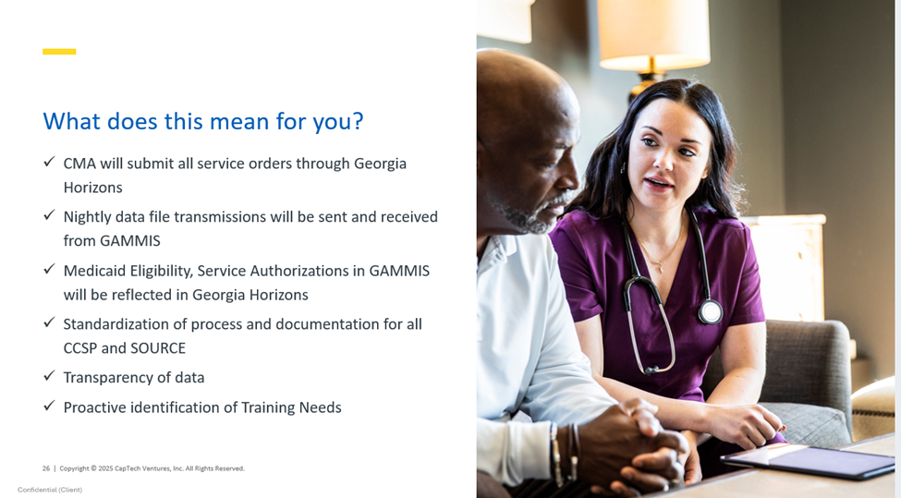

- Structured Family Caregiving
  - Structured Family Caregiving (SFC) has been identified as a high-risk service category. In response, DCH is implementing a series of policy and operational enhancements designed to strengthen program integrity, promote consistency, and support appropriate service delivery across the provider network.
  - More detailed information will be forthcoming in a GAMMIS Banner message so please be on the lookout. Insight on upcoming changes includes:
    - Electronic Visit Verification
    - Participation in Yearly Caregiver Curriculum
    - Daily RN Monitoring of Member Notes
    - Background Check via GCHEXS (with recheck every 3 years) ***to include FBI screening/monitoring
    - Caregiver Certification
    - National Committee for Quality Assurance Accreditation (NCQA)
    - SFC Caregiver Curriculum and Training Plan
    - Will apply to Expansions/Change in Ownership
    - Existing Providers: Will have until 09/01/27 to comply or will be disenrolled as a providing SFC within EDWP. No ‘Grandfathered’ In protections will apply
  - Enrollment will resume March 2027
    - Application fee (to be paid every three years)
    - Completion of Gainwell Onsite Visit (to be paid every three years)
    - NCQA Accreditation (Case Management with Distinction in LTSS)
    - SFC Caregiver Curriculum and Training Plan
    - State/FBI Background Checks and Fingerprinting for all owners with 5% or greater ownership interest (to be paid every three years)
    - March is the designated month to enroll prospective SFC Providers. No other provider application types will be accepted during this time. By having a single annual enrollment period it would minimize duplication of effort, easing the burden on both providers and DCH staff. Consolidated efforts enable focused verification of provider legitimacy. Enables better monitoring of provider changes including ownership transfers, service expansions, and terminations.

- Referrals: Educate the potential members and their potential paid family
caregivers that the members must meet a NH level of care and financial requirements for the EDWP program. All MEDICAID CATEGORIES are not allowed in EDWP.
  - Key component is to ensure we have viable referrals to our programs.
  - There are expectations with those family caregivers to include EVV within family hire, drafting daily notes within SFC, and compliance training to help equip our family hires.
  - When talking with potential members interested in EDWP-moving forward SSN# is a REQUIREMENT for EDWP screening. Start having these conversations that this will be required for them to provide. Client record cannot be created without this information.

- HCBS STP QA Compliance by Alliant
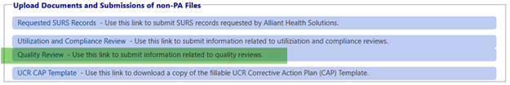
  - How to check for an active QA Review: The providers should go to the GAMMIS Provider Web Portal, Prior Authorization, Medical Review Portal, Upload Documents and Submissions of non-PA Files:
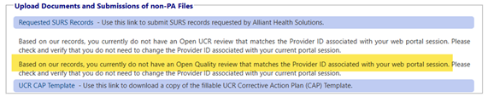
  - If the provider does not have a review, they will see the following message below

- Revalidation
  - Banner Message posted on 5/15/2026
  - Federal regulations require State Medicaid Agencies to revalidate the enrollment of all providers, regardless of provider type, at least every five years (42 CFR 455.414). The revalidation process requires an enrolled provider to confirm the accuracy of its enrollment information and to make corrections where appropriate.
  - The Department has identified several providers that have not revalidated their enrollment in accordance with federal regulations. A complete listing of the providers who have not submitted a revalidation application can be found online on the GAMMIS website at www.mmis.georgia.gov. Once you reach the landing page, select the “Provider Information” tab at the top of the page. Then select “Reports for Public Access.” Select the report titled “Provider Revalidation Past Due by Provider Type.”
  - Effective July 1, 2026, DCH will suspend the enrollment of those providers who have failed to revalidate their enrollment. As a result, suspended providers will not be able to participate in the Georgia Medicaid/PeachCare for Kids programs. The suspension will apply to providers serving Traditional Fee-for-Service Medicaid members, PeachCare for Kids members, and the Georgia Families and Georgia Families 360 managed care programs which are administered by Amerigroup, CareSource, and Peach State Health Plan. Claims with dates of service on or after July 1, 2026, will not be paid.
  - Upon successfully completing the revalidation process, your suspension will be lifted. However, your effective date will be the date that you submit your revalidation application. Retro-enrollment is NOT applicable in this instance. Should you fail to revalidate your enrollment within thirty (30) days of receipt of the suspension letter, you will receive a notice of termination from DCH. The notice of termination will outline your appeal rights.

- Restraints and Alternative Measures to Restrictive Interventions presentation will be included with this meeting agenda. It is imperative that each agency review and begin to include in training materials for all staff.

- EDWP Reminders

  - EDWP communication must be submitted via email to ccsp.messages@dch.ga.gov in order for the EDWP team to address.
  - Critical Incident reporting: Unless the CI resulted in a post on social media, or on the news, please do not select media on your CI reporting. We are still seeing this used incorrectly regularly.

