WAIVER | WAIVER Specialists
Independent Care Waiver (ICWP) Lead | Kimberlee Boulding  Kimberlee.boulding@dch.ga.gov  470-585-7410
CCSP/SOURCE (EDWP) Waiver Leads  NOW/COMP Waiver Lead | Andrea Streeter  Andrea.Streeter@dch.ga.gov  470-515-6302  Briana Coogler  Briana.coogler@dch.ga.gov  470-456-5482  Marina Kim  Marina.kim@dch.ga.gov  404-904-7647  Shandria Beasley  Shandria.beasley@dch.ga.gov  470-393-1980
General EDWP Waiver Questions | ccsp.messages@dch.ga.gov
General ICWP Waiver Questions | Icwp.messages@dch.ga.gov
Georgia Pediatric Program | Sharon Collins 404.683.5113  scollins@dch.ga.gov
Director of Program and Community Supports (Waivers, LTC, STP, and MFP) | Taesha Ward 470-895-2777  Taesha.ward3@dch.ga.gov
Program and Community Supports Compliance Manager | Vonnie Stelly 470-542-9402  VStelly@dch.ga.gov
Prior Authorization Claims Resolution Manager | Donna Elrod 470-522-9620  donna.elrod@dch.ga.gov

**** Use the Contacts below before emailing the waiver team.

____________________________________________________________________

Billing issues should start with your Gainwell field rep, then Donna Elrod.

Suspensions, revalidation, anything related to your Medicaid contract should be emailed to Provider Enrollment to enrollment@dch.ga.gov.

The Georgia Department of Community Health, HCBS Waiver incident reporting system:

The HCBS Incident Report can be accessed at -
HCBS Incident Reporting System | Georgia Medicaid

Additionally, we have a resources page to assist in training agency staff.

Link to resource page:
https://medicaid.georgia.gov/programs/all-programs/waiver-programs/hcbs-incident-reporting-system-resources

For questions or technical assistance, please reach out to tech.solutions@dch.ga.gov

General Services Manual - suspending referrals to providers for failure to report incidents. The responsibility for submission of an incident report falls on the first person to witness or discover the incident regardless of location
Other Contacts

- DXC, 1-800-766-4456

- Provider Enrollment enrollment@dch.ga.gov

- Revalidation, enrollment@dch.ga.gov

- CVO, 1 800-766-4456 outreachsupport@verisys.com

- Gainwell- Gainwell Field Representative assistance- GAMMIS website, www.MMIS.georgia.gov, select Contact Information tab, then Contact Us tab. Choose the applicable drop-down from the list. Call 800-766-4456.

Finding a list of active Medicaid providers in GA
https://dch.georgia.gov/ click on ‘providers’ and ‘provider directory’

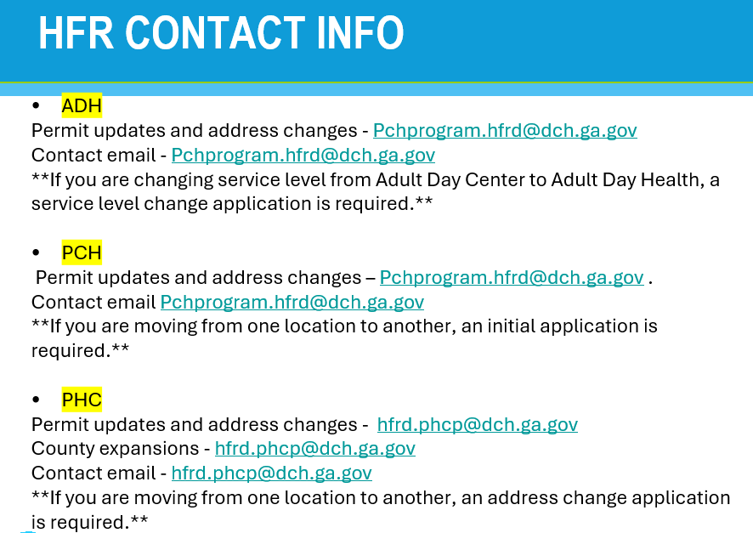

Healthcare Facility Regulation (HFR)- proxy forms/find a facility/complaints
https://dch.georgia.gov/divisionsoffices/hfrd

EDWP Referral Process- AAA contact information-
https://aging.georgia.gov/locations

Online referral system for CCSP referrals to the appropriate AAA- link below

https://hssgaprod.wellsky.com/assessments/?WebIntake=2CBCF6CD-9412-4839-8EF8-5864FA6BA0F9

*The link above is the best way for providers to submit 3rd party referrals if they aren’t sure where they need to go.

ATLANTA 404-463-3333.
CSRA 888-922-4464 and 706-210-2018
Coastal 800-580-6860
Georgia Mountains (Legacy Link) 800-845-5465 and 770-538-2650
Heart 888-367-9913 and 912-367-3648
Middle 478-751-6466
NE 800-474-7540 and 706-583-2546
NW 800-759-2963 and 706-802-5506
River Valley (706) 256-2900 and 800-615-4379
Southern 888-732-4464 and 912-287-5888
SOWEGA 800-282-6612 and 229-432-1124
Three Rivers 866-854-5652 and 678-552-2838
* 866-552-4464, Option 2

Policy Revisions included in the January 2026 Edition of the EDWP Policy Manuals: Remember to review the manuals quarter for policy updates across all four waivers.

Network Meeting attendance-
EDWP Provider Network Meetings consists of statewide meetings in the form of a webinar that are hosted by the Atlanta Regional Commission (ARC).
Providers must go to https://www.empowerline.org/for-professionals/medicaid-elderly-and-disabled-waiver-providers-meeting-information/ to register for each meeting ahead of time. Once registered, each provider will receive a confirmation e-mail that includes the link to join the webinar at the specified time and date.
All network meeting information and presentations will be placed on the ARC Network Meeting webpage.
Policy has been updated January 1, 2026 to require providers must attend all (4) network meetings. General Services Manual. Corrective action will be applied for those providers who are not in compliance.
*Network meeting reminders will ONLY be sent to agencies that have registered at the site to receive the reminders. We encourage all providers to register their email address at the registration site so that they will receive the reminders for themselves.

The format has the capability for DCH to track the time of logging on and off of the meeting for each provider. You must participate in the full meeting to receive credit for attending.

EVV information-

Handouts and recordings- EVV Service Providers | Georgia Medicaid

Tellus Training Webinars- Tellus | EVV Software & Claims Processing For Home Health/Long Term Care (4tellus.com)

Email questions to……Evv.medicaid@dch.ga.gov or visit
https://medicaid.georgia.gov/georgia-electronic-visit-verification

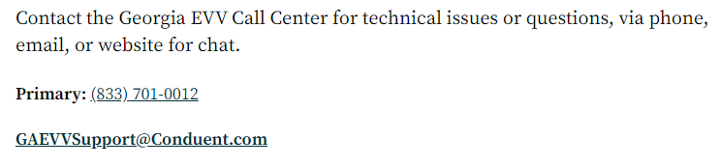

Waiver Updates:

- EDWP communication must be submitted via email to ccsp.messages@dch.ga.gov in order for the EDWP team to address.
- Critical Incident reporting: Unless the CI resulted in a post on social media, or on the news, please do not select media on your CI reporting. We are still seeing this used incorrectly regularly.
- HCBS Settings Rule Disenrollment: Disenrollment letters were sent out 2 weeks ago. Case management agencies must follow up with clients to rebroker services in order to limit disruption in services.
- Policies and Procedures: Requirements regarding provider compliance, adverse action, and corrective action procedures are outlined in the following manuals:
  - Part I Policies and Procedures for Medicaid and PeachCare for Kids: Chapter 400
  - Part II Policies and Procedures for EDWP-CCSP and SOURCE General Services Manual: Chapter 608
  - Part II Policies and Procedures for Independent Care Waiver Services (ICWP): Chapter 603

hcbstranstions@dch.ga.gov - For technical assistance and questions re: Settings Rule/Statewide Transition Plan

Please review our website for updated information regarding the waiver programs. Georgia Medicaid

- Structured Family Caregiving
  - Applications for new and expansion are currently on hold.
  - Remember SFC is NOT a program, it is a service within EDWP therefore a person must meet the eligibility requirements for the EDWP program.
  - The cost share may not be drafted from the paid caregiver’s stipend but paid directly from the member enrolled in the EDWP program
  - For daily notes: must be monitored by Health coach and agency RN must review these notes at least every 14 days and provide a signature that the review has been completed.
- SFC supervisory visit requirements will be added as an amendment to the January 1, 2026 policy that providers will have until July 2026 to implement this requirement.

- Referrals: Educate the potential members and their potential paid family
caregivers that the members must meet a NH level of care and financial requirements for the EDWP program. All MEDICAID CATEGORIES are not allowed in EDWP.
  - Key component is to ensure we have viable referrals to our programs.
  - There are expectations with those family caregivers to include EVV within family hire, drafting daily notes within SFC, and compliance training to help equip our family hires.
- January 2026 Policy Updates
  - No changes – HDM, ADH, ALS, ERS, Out of Home Respite, HDS
  - General Services Manual
    - Appendix L (Utilization Review/Appeal process)-Language Change from DHS to DCH Legal Services
    - Appendix T (AAA Services Areas)-Correction of AAA Phone Numbers
    - Appendix W (AAA Consult Form)-AAA Consult SOP (must be completed within 5 business days)
    - Appendix DD (Application Checklist Table)- SFC Business Plan Requirement
    - Section 605.1.27- Conflict of Interest Federal Regulations
    - Section 605.1.27.1- Website re conflict of interest: eCFR :: 42 CFR 438.810 -- Expenditures for enrollment broker services
    - Section 608.1.2.12- Provider Network attendance requirement (all four (4))
    - Section 607.2.2.9- Expansion Clarification (six (6) months)
  - Case Management Manual
    - Section 2003- Updated to DCH Legal Services from DHS Legal Services
    - Section 1992- Appeal Email address Medicaid.appeals@dch.ga.gov
    - Section 1867.8- Removal of Notice of Status of Request for Services
  - Personal Support Services
    - Section 1413.11.1- Consumer Direct Option Back Up Provider Requirement
      - The CDO Backup Plan may be used with prior approval from Case Management. Prior approval is required for the Fiscal Agent to authorize payment to the backup agency.
    - Section 1417.2.2.2- SFC Semi-Annual Visit Requirement (every six (6) months)
    - Section 1417.2.8- SFC Ongoing Fingerprinting Requirement
      - If previously enrolled under long-term care, providers and/or caregivers may only receive a new satisfactory letter and not a fingerprinting appointment
    - Section 1417.2.8.2- SFC Supervisory Visit Requirement
    - Section 1417.4.6- CPR/First Aid Requirement permitted Online (for SFC only) and In Person
**Only SFC is permitted to obtain online certification for CPR and First Aid certification.**

- Program and LOC Requirements
  - EDWP (CCSP and SOURCE) assists individuals who are 21 and over and functionally impaired to continue living in their own homes and communities as an alternative to nursing home placement. Individuals served by the program are required to meet the same level of care for admission to a nursing facility and be Medicaid eligible or potentially Medicaid eligible. Applicants with primary psychiatric, developmental or congenital conditions will be referred to other appropriate services.
      - EDWP is not solely for sensory impairment or intellectual disability as waivers ICWP and NOW/COMP are focused with servicing individuals with these diagnosis.
- EDWP Reminders
  - Providers requesting PSS being added to Authorizations when PSSX has not been served
    - General Services 312.20.1.8, it states,
    - NOTE: If visit(s) is (are) shortened or omitted due to a member’s absence, the provider may submit a completed EDWP Notification Form on the last working day of that month.
    - The EDWP Notification Form must be used to notify Case Management of emergency frequency changes that occur and need adjustments made to the PA.
    - Examples- PSSX care cut short and PSS units need added to the PA on GAMMIS, ADH full day cut short and ADH partial day needs added.
  - If a Medicaid Member loses their SSI and they are receiving services in SOURCE, AT THIS TIME, the member should be transitioned to CCSP and have EDWP Medicaid established.
    - Clients should not be terminated and all transfer and assessment protocols would need to be followed as outlined in the EDWP Case Management Manual page 105.
    - Clients requesting a move from SOURCE to Traditional/ Enhanced EDWP will be screened by the ADRC, with use of the ‘waiver transfer form’ and ‘transfer supplement’ sent by the Source site to the AAA and sent for the nurse initial assessment without placement on a waiting list. The screening assessment/performance of the DON-R is not necessary for these cases. Input general demographics and process the file to the Case Management.
    - Processing SSI loss to Gateway for EDWP Category - Upon receipt of file from the AAA to the electronic data system, upload the CCC and LOC to Gateway within 3 business days for liability determination. Utilize the signed LOC from the SOURCE site if member is leaving SOURCE and moving to CCSP.

Georgia Horizons

