WAIVER | WAIVER Specialists
Independent Care Waiver (ICWP) Lead | Kimberlee Boulding  Kimberlee.boulding@dch.ga.gov  470-585-7410
CCSP/SOURCE (EDWP) Waiver Leads  NOW/COMP Waiver Lead | Andrea Streeter  Andrea.Streeter@dch.ga.gov  470-515-6302  Briana Coogler  Briana.coogler@dch.ga.gov  470-456-5482  Marina Kim  Marina.kim@dch.ga.gov  404-904-7647  Shandria Beasley  Shandria.beasley@dch.ga.gov  470-393-1980
General EDWP Waiver Questions | ccsp.messages@dch.ga.gov
General ICWP Waiver Questions | Icwp.messages@dch.ga.gov
Georgia Pediatric Program | Sharon Collins 404.683.5113  scollins@dch.ga.gov
Director of Program and Community Supports (Waivers, LTC, STP, and MFP) | Taesha Ward 470-895-2777  Taesha.ward3@dch.ga.gov
Program and Community Supports Compliance Manager | Vonnie Stelly 470-542-9402  VStelly@dch.ga.gov
Prior Authorization Claims Resolution Manager | Donna Elrod 470-522-9620  donna.elrod@dch.ga.gov

**** Use the Contacts below before emailing the waiver team.

____________________________________________________________________

Billing issues should start with your Gainwell field rep, then Donna Elrod.

Suspensions, revalidation, anything related to your Medicaid contract should be emailed to Provider Enrollment.

The Georgia Department of Community Health, HCBS Waiver incident reporting system:

The HCBS Incident Report can be accessed at -
HCBS Incident Reporting System | Georgia Medicaid

Additionally, we have a resources page to assist in training agency staff.

Link to resource page:
https://medicaid.georgia.gov/programs/all-programs/waiver-programs/hcbs-incident-reporting-system-resources

For questions or technical assistance, please reach out to the HCBS Waiver Unit at: HCBS.IncidentReports@dch.ga.gov.

General Services Manual - suspending referrals to providers for failure to report incidents. The responsibility for submission of an incident report falls on the first person to witness or discover the incident regardless of location
Other Contacts

- DXC, 1-800-766-4456

- Provider Enrollment enrollment@dch.ga.gov

- Revalidation, revalidationenrollment2@dch.ga.gov

- CVO, 1 800-766-4456 outreachsupport@verisys.com

- Gainwell- Gainwell Field Representative assistance- GAMMIS website, www.MMIS.georgia.gov, select Contact Information tab, then Contact Us tab. Choose the applicable drop-down from the list. Call 800-766-4456.

Finding a list of active medicaid providers in Ga
https://dch.georgia.gov/ click on ‘providers’ and ‘provider directory’

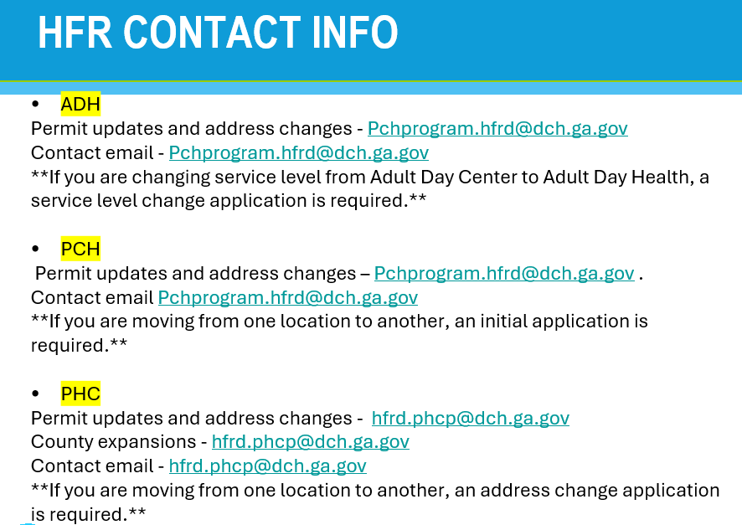

Healthcare Facility Regulation (HFR)- proxy forms/find a facility/complaints
https://dch.georgia.gov/divisionsoffices/hfrd

EDWP Referral Process- AAA contact information-
https://aging.georgia.gov/locations

Online referral system for CCSP referrals to the appropriate AAA- link below

https://hssgaprod.wellsky.com/assessments/?WebIntake=2CBCF6CD-9412-4839-8EF8-5864FA6BA0F9

*The link above is the best way for providers to submit 3rd party referrals if they aren’t sure where they need to go.

ATLANTA 404-463-3333.
CSRA 888-922-4464
Coastal 800-580-6860
Georgia Mountains (Legacy Link) 855-266-4283
Heart 888-367-9913
Middle 888-548-1456
NE 888-808-8020
NW 800-759-2963
River Valley (706) 256-2900
Southern 888-732-4464
SOWEGA 800-282-6612
Three Rivers 866-854-5652
* 866-552-4464, Option 2

Policy Revisions included in the July 2025 Edition of the EDWP Policy Manuals: Remember to review the manuals quarter for policy updates across all four waivers.

Network Meeting attendance-
EDWP Provider Network Meetings consists of statewide meetings in the form of a webinar that are hosted by the Atlanta Regional Commission (ARC).
Providers must go to https://www.empowerline.org/for-professionals/medicaid-elderly-and-disabled-waiver-providers-meeting-information/ to register for each meeting ahead of time. Once registered, each provider will receive a confirmation e-mail that includes the link to join the webinar at the specified time and date.
All network meeting information and presentations will be placed on the ARC Network Meeting webpage.
Policy will be updated January 1, 2026 to require providers must attend all (4) network meetings. Current policy requires the attendance of two (2) network meetings per FISCAL (July 1 – June 30) year. General Services Manual. Corrective action can be applied for those providers who are not in compliance.
*Network meeting reminders will ONLY be sent to agencies that have registered at the site to receive the reminders. We encourage all providers to register their email address at the registration site so that they will receive the reminders for themselves.

The format has the capability for DCH to track the time of logging on and off of the meeting for each provider. You must participate in the full meeting to receive credit for attending.

EVV information-

Handouts and recordings- EVV Service Providers | Georgia Medicaid

Tellus Training Webinars- Tellus | EVV Software & Claims Processing For Home Health/Long Term Care (4tellus.com)

Email questions to……Evv.medicaid@dch.ga.gov or visit
https://medicaid.georgia.gov/georgia-electronic-visit-verification

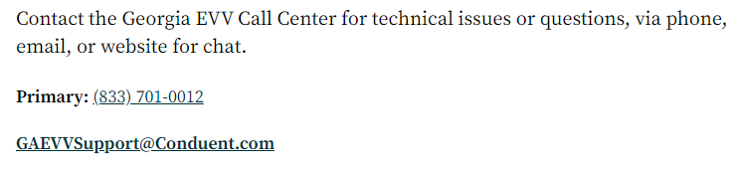

Waiver Updates:

- EDWP communication must be submitted via email to ccsp.messages@dch.ga.gov in order for the EDWP team to address.
- Only one communication to one person is permitted to allow that EDWP staff member to respond; please refrain from sending the same communication to multiple individuals
- Critical Incident reporting: Unless the CI resulted in a post on social media, or on the news, please do not select media on your CI reporting. We are still seeing this used incorrectly regularly
- Settings Rule: At this time, the grace period for the HCBS settings rule has ended. Providers that have not been compliant with the settings requirements will be disenrolled and clients will be rebrokered.

Alliant Health Solutions is actively conducting validation activities to ensure provider settings meet the federal HCBS Settings Rule requirements. Providers identified for validation must submit all requested documentation via the Medicaid Review Portal.
  - Alliant Health Solutions has issued initial notifications to all providers with outstanding documentation.
  - Providers who have not responded will receive two additional outreach attempts following the initial “Contact Us Inquiry.”
  - Timely submission of all requested documentation is required to avoid adverse actions.
Policies and Procedures: Requirements regarding provider compliance, adverse action, and corrective action procedures are outlined in the following manuals:
  - Part I Policies and Procedures for Medicaid and PeachCare for Kids: Chapter 400
  - Part II Policies and Procedures for EDWP-CCSP and SOURCE General Services Manual: Chapter 608
  - Part II Policies and Procedures for Independent Care Waiver Services (ICWP): Chapter 603

hcbstranstions@dch.ga.gov - For technical assistance and questions re: Settings Rule/Statewide Transition Plan

In addition to Alliant's validation efforts, DCH will make the necessary referrals to Office of Inspector General, HFRD, Ombudsman when deemed necessary. Waiver team are reviewing case managements case notes to see if it aligns with Alliant reports where violations have been reported.

There will be a new platform where service providers can attend virtual training regarding the settings rule in the upcoming months.

Please review our website for updated information regarding the waiver programs. Georgia Medicaid

- Structured Family Caregiving
  - Applications for new and expansion are currently on hold.
  - Remember SFC is NOT a program, it is a service within EDWP therefore a person must meet the eligibility requirements for the EDWP program.
  - The cost share may not be drafted from the paid caregiver’s stipend but paid directly from the member enrolled in the EDWP program
  - For daily notes: must be monitored by Health coach and agency RN must review these notes at least every 14 days and provide a signature that the review has been completed.
  - Examples of misleading advertising:
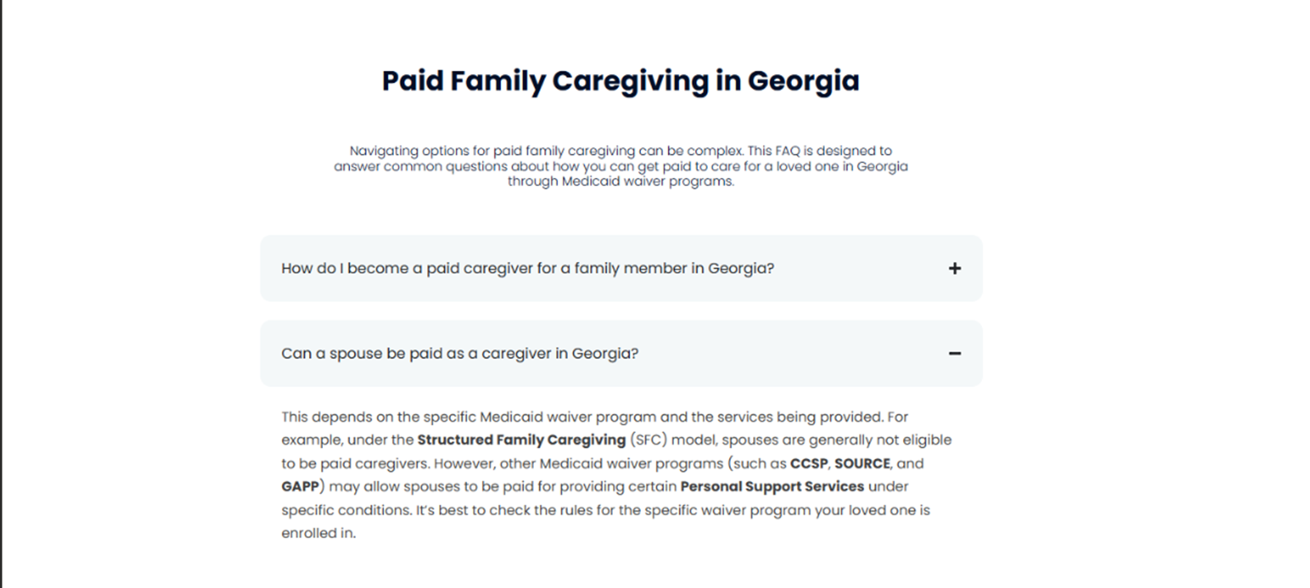
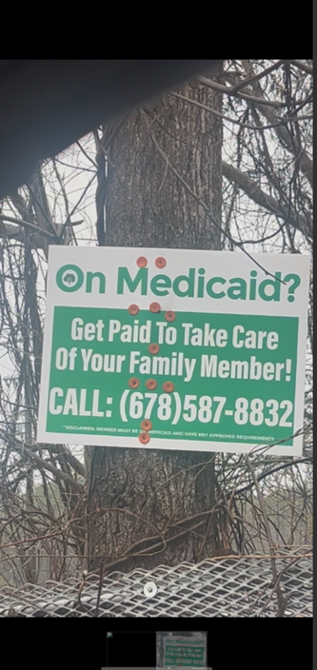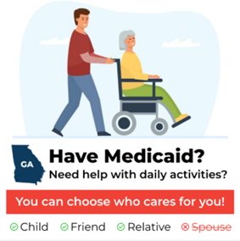
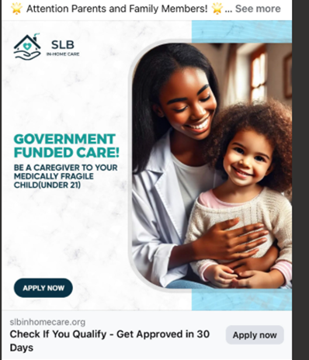
- Referrals: Educate the potential members and their potential paid family
caregivers that the members must meet a NH level of care and financial requirements for the EDWP program. All MEDICAID CATEGORIES are not allowed in EDWP.
  - Key component is to ensure we have viable referrals to our programs.
  - There are expectations with those family caregivers to include EVV within family hire, drafting daily notes within SFC, and compliance training to help equip our family hires.
- October 2025 Policy Updates
  - No updates:
    - HDM, ERS, ALS, SN and out of home respite
  - Personal Support Services
    - 1417.4.6. Must obtain and maintain active CPR and First Aid certification. This applies to caregivers hired on or after October 1, 2025. ** Can be virtual or in person** *Appendix D has been updated to reflect update*
    - 1417.4.9. They are responsible for supporting the member to maximize the highest level of independence possible by providing necessary care and support, including the following:
      - 1417.4.9.1. Supervision or assistance in performing ADLs;
      - 1417.4.9.2. Supervision or assistance in performing IADLs;
      - 1417.4.9.3. Protective supervision provided solely to assure the health and welfare of a recipient;
      - 1417.4.9.4. Supervision or assistance with health-related tasks;
      - 1417.4.9.5. Supervision or assistance while escorting/accompanying the member outside of the home to perform tasks, including IADLs, health maintenance or other needs as identified in the care plan and to provide the same supervision or assistance as would be rendered in the home; and
      - 1417.4.9.6. Submission of daily notes/tasks and applicable notes electronically which reflect the member’s health and the caregiver’s performance. The daily notes/tasks must be available to the CCSP or SOURCE case manager
  - General Services
    - 601.3.3. To involve the member or member’s representative in the provision and decision-making process regarding member care. Across and within all HCBS Waiver Programs, a non-family representative cannot represent more than three(3) waiver participants
    - 607.2.2.3. Providers seeking expansion of county coverage for an existing service must have been EDWP (CCSP and SOURCE) providers for a minimum of twelve (12) months.
    - Appendix M and Appendix DD have been updated to reflect the above policy references.
  - Case Management
    - 1875.8. Use the MDS-HC to complete a comprehensive evaluation of the applicant’s medical status and health functional ability and available resources. Analyze and interpret medical and social information as compiled. Obtain additional information as needed, requesting medical record information from the physician or the agency’s Medical Director, using the EDWP Physicians Evaluation form. Medical records are required to be submitted with ALL Initial Assessments. Medical records must support the following:
      - 1875.9. Assessments that reflect functional impairment not clearly associated with a medical diagnosis
      - 1875.10. Assessments that reflect one or more behavioral health diagnoses with functional impairment not clearly associated with a medical diagnosis
      - 1875.11. Assessments that reflect diagnoses not typically expected to result in long term functional impairment such as hip fracture or knee replacement Alliant Health Solutions and/or DCH staff may request and/or retrieve additional medical records to support any level of care determination. The request is for the purpose of determining eligibility. Information may include hospitalization information, medical equipment needs, previous treatment, and medical history.
    - 1965.3.4. Complete the transfer form and upload to Alliant, notifying Alliant Health Solutions (AHS) via “contact us” of the need for the PA transfer. Upload the completed form as well as the current/signed/approved LOC page in formal notes in the electronic data system. Waiver Transfer Form (40) and Supplement Checklist (66) must be completed electronically
    - 2085.11. Medical records are required to be submitted with ALL Initial Assessments. Medical records must support the following:
      - 2085.11.1. Assessments that reflect functional impairment not clearly associated with a medical diagnosis
      - 2085.11.2. Assessments that reflect one or more behavioral health diagnoses with functional impairment not clearly associated with a medical diagnosis Page 265 of 309
      - 2085.11.3. Assessments that reflect diagnoses not typically expected to result in long term functional impairment such as hip fracture or knee replacement
  - ADH
    - Elderly and Disabled Waiver members living in ALS facilities may receive services at an Adult Day Health Services facility for up to 2 full days per week, no more than 3 half days.

- Program and LOC Requirements
  - EDWP (CCSP and SOURCE) assists individuals who are 21 and over and functionally impaired to continue living in their own homes and communities as an alternative to nursing home placement. Individuals served by the program are required to meet the same level of care for admission to a nursing facility and be Medicaid eligible or potentially Medicaid eligible. Applicants with primary psychiatric, developmental or congenital conditions will be referred to other appropriate services.
      - EDWP is not solely for sensory impairment or intellectual disability as waivers ICWP and NOW/COMP are focused with servicing individuals with these diagnosis.
  - Ensure that section 601 of the General Services manual is utilized when assessing potential and current clients for nursing home level of care to focus on IADL and ADL requirement. Functional impairment caused by physical limitations such as Alzheimer’s and other types of dementia are physical conditions (1855.1 C
  - EDWP is for sensory impairment, intellectual disability, and may not understand how those diagnoses are different from a diagnosis of functional impairment. (2068
  - Summary for Intermediate Nursing home LEVEL OF CARE CRITERIA and EDWP Program guidelines are found in 2072.10:
    - 2072.10.1. Services may be provided to an individual with a stable medical condition requiring intermittent skilled nursing services under the direction of a licensed physician (Column A Medical Status) AND either a mental/ cognitive (column B) and/or functional impairment that would prevent self-execution of the required nursing care (Column C Functional Status).
    - 2072.10.2. Special attention should be given to cases where psychiatric treatment is involved. A patient is not considered appropriate for intermediate care services when the primary diagnosis or the primary needs of the patient are psychiatric or related to a developmental disability rather than medical need. This individual must also have medical care needs that meet the criteria for intermediate care facility placement. In some cases, a patient suffering from mental illness may need the type of services which constitute intermediate care because the mental condition is secondary to another more acute medical disorder.

- Georgia Horizons Presentation

