WAIVER | WAIVER Specialist
EDWP Provider Specialist  ICWP Lead | Vonnie Stelly  VStelly@dch.ga.gov 470-542-9402
EDWP Case Management Specialist  CCSP SOURCE Lead | Jill Crump  Jill.Crump@dch.ga.gov 404 357 0161
EDWP changes/questions/ALS F Registrations | ccsp.messages@dch.ga.gov
GAPP | Sharon Collins 404.683.5113  scollins@dch.ga.gov
Sr Mgr, Business Ops | Ashley Livers 404.709.0248  ashley.livers@dch.ga.gov
Director, Program and Community Support | Taesha Ward 470-895-2777  Taesha.ward3@dch.ga.gov
PA Management/Claims Resolution | Donna Elrod  donna.elrod@dch.ga.gov 470-522-9620

____________________________________________________________________

The Georgia Department of Community Health, HCBS Waiver incident reporting system:

The HCBS Incident Report can be accessed at -
HCBS Incident Reporting System | Georgia Medicaid

Additionally, we have a resources page to assist in training agency staff.

Link to resource page:
https://medicaid.georgia.gov/programs/all-programs/waiver-programs/hcbs-incident-reporting-system-resources

For questions or technical assistance, please reach out to the HCBS Waiver Unit at: HCBS.IncidentReports@dch.ga.gov.

General Services Manual 602.1B- suspending referrals to providers for failure to report incidents. 601.6- The responsibility for submission of an incident report falls on the first person to witness or discover the incident regardless of location or whether during the point of service.
Other Contacts

- DXC, 1-800-766-4456

- Provider Enrollment enrollment@dch.ga.gov

- Revalidation, revalidationenrollment2@dch.ga.gov

- CVO, 1 800-766-4456 outreachsupport@verisys.com

- Gainwell- Gainwell Field Representative assistance- GAMMIS website, www.MMIS.georgia.gov, select Contact Information tab, then Contact Us tab. Choose the applicable drop-down from the list. Call 800-766-4456.

Finding a list of active medicaid providers in Ga
https://dch.georgia.gov/ click on ‘providers’ and ‘provider directory’

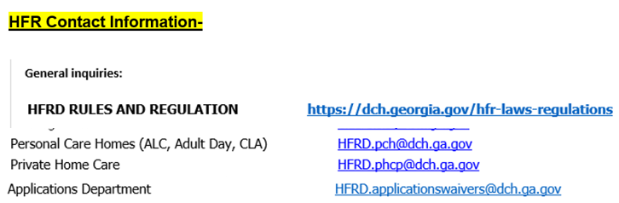

Healthcare Facility Regulation (HFR)- proxy forms/find a facility/complaints
https://dch.georgia.gov/divisionsoffices/hfrd

EDWP Referral Process- AAA contact information-
https://aging.georgia.gov/locations

Online referral system for CCSP referrals to the appropriate AAA- link below

https://hssgaprod.wellsky.com/assessments/?WebIntake=2CBCF6CD-9412-4839-8EF8-5864FA6BA0F9

*The link above is is the best way for providers to submit 3rd party referrals if they aren’t sure where they need to go.

ATLANTA 404-463-3333.
CSRA 888-922-4464
Coastal 800-580-6860
Georgia Mountains (Legacy Link) 855-266-4283
Heart 888-367-9913
Middle 888-548-1456
NE 888-808-8020
NW 800-759-2963
River Valley (706) 256-2900
Southern 888-732-4464
SOWEGA 800-282-6612
Three Rivers 866-854-5652
* 866-552-4464, Option 2

Policy Revisions included in the January 2024 (SFY 24) Edition of the EDWP Policy Manuals: Attached

Network Meeting attendance-
EDWP Provider Network Meetings consists of statewide meetings in the form of a webinar that are hosted by the Atlanta Regional Commission (ARC).
Providers must go to https://www.empowerline.org/for-professionals/medicaid-elderly-and-disabled-waiver-providers-meeting-information/ to register for each meeting ahead of time. Once registered, each provider will receive a confirmation e-mail that includes the link to join the webinar at the specified time and date.
All network meeting information and presentations will be placed on the ARC Network Meeting webpage.
Policy requires the attendance of two (2) network meetings per FISCAL (July 1 – June 30) year. Gen Services Manual Pg. VI-14. Corrective action can be applied for those providers who are not in compliance.
*Network meeting reminders will ONLY be sent to agencies that have registered at the site to receive the reminders. We encourage all providers to register their email address at the registration site so that they will receive the reminders for themselves.

The web-x format has the capability for DCH to track the time of logging on and off of the web-x for each provider. You must participate in the full web-x to receive credit for attending.

EVV information-

Schedule of events- EVV Schedule of Events | Georgia Medicaid
Handouts and recordings- EVV Service Providers | Georgia Medicaid

Tellus Training Webinars- Tellus | EVV Software & Claims Processing For Home Health/Long Term Care (4tellus.com)

Email questions to……Evv.medicaid@dch.ga.gov or visit
https://medicaid.georgia.gov/georgia-electronic-visit-verification

