Policy Revisions included in the July 2022 Edition of the
CCSP and SOURCE Policy Manuals
Revision Date | Section | Description of Revision | Revision Type | Citation
07/01/2022 | 1403.3 CCSP and SOURCE Personal Support/Consumer Direction/Structured Family Care | Updates policy regarding clinical records and EVV language. | Policy Clarification/Update | DCH Policy
07/01/2022 | 1405, 1406 and 1407.3 CCSP and SOURCE Personal Support/Consumer Direction/Structured Family Care | Updates policy regarding In/Out of State aide travel for Traditional, Cd PSS and SFC as well as out of Country | Policy Clarification/Update | DCH Policy
07/01/2022 | 1407.4 CCSP and SOURCE Personal Support/Consumer Direction/Structured Family Care | Updates policy regarding caregiver eligibility and two members in the same household on SFC. | Policy Clarification/Update | DCH Policy
07/01/2022 | Appendix X Chapter 600-1000 EDWP General Services Manual | Updates contact information for Gainwell Technologies | Policy Clarification/Update | DCH Policy
07/01/2022 | 604.1A4 Chapter 600-1000 EDWP General Services Manual | Clarifies member freedom of choice of provider. | Policy Clarification/Update | DCH Policy

1403.3 Clinical Records

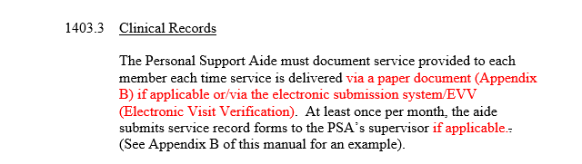
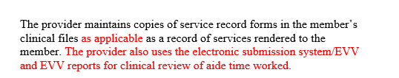

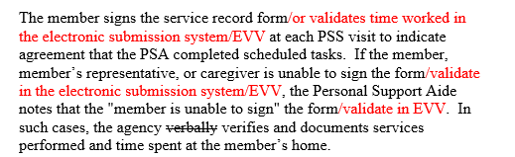

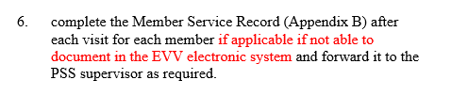

1405

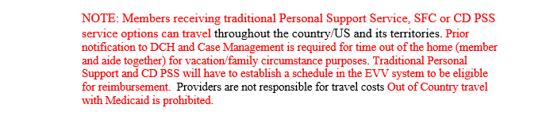

1406
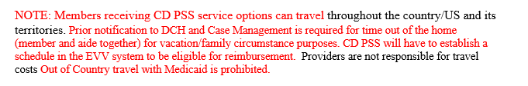

1407

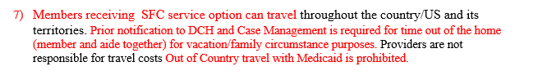
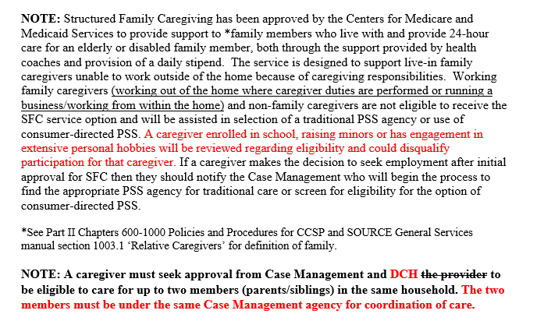

Appendix X- below

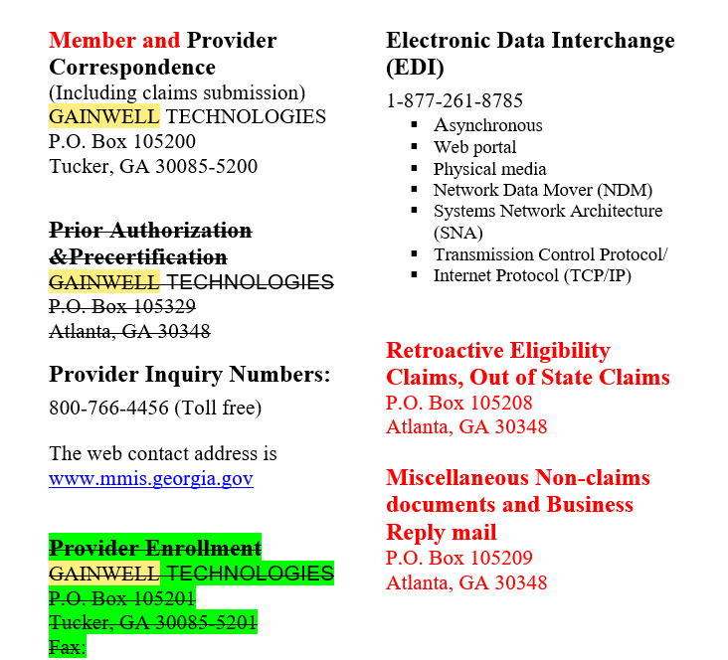

604.1A4

